NAME : TULSI RAWANI AGE: 52 Y/ M DATE: 15 January 2026
Refd. By.: DR. A K SINGH MBBS, UCMS, MS(G. SURGERY), FIAGES, FMAS, USMLE(USA), DNB(I), FICS, EISE, ECGMG(USA), MCh(NEUROSURGERY)
====================================================================
This Scan has been Proudly done on Brand New, Most Advanced 3 Tesla MRI

M.R.I. STUDY OF BRAIN

Technique
MRI Brain performed using standard sequences including T1, T2, FLAIR, DWI/ADC, GRE/SWI.

Findings
- Parenchyma:
  - Small acute haemorrhagic contusion noted in the left parietal region.
  - Associated SWI blooming consistent with blood products.
  - No significant mass effect or midline shift.
  - Surrounding parenchyma shows mild edema.
- Grey and White Matter: Preserved cortical and subcortical architecture. No evidence of diffuse axonal injury.
- Ventricles and CSF Spaces: Normal in size and configuration. No hydrocephalus.
- Basal Ganglia, Thalami, Brainstem, and Cerebellum: Appear normal. No focal lesions.
- Extra-axial Spaces: No subdural or epidural collection detected.
- Scalp/Soft Tissues:
  - Scalp oedema present.
- Vascular Flow Voids: Preserved. No abnormal signal suggestive of vascular malformation.
- Sinuses and Orbits: Visualized portions are unremarkable.

Impression
- Small acute haemorrhagic contusion in the left parietal region with SWI blooming.
- Scalp oedema.
- No significant mass effect or midline shift.
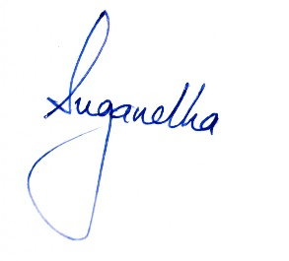
- No other acute intracranial abnormality detected.

